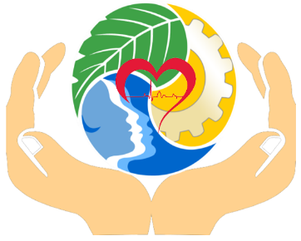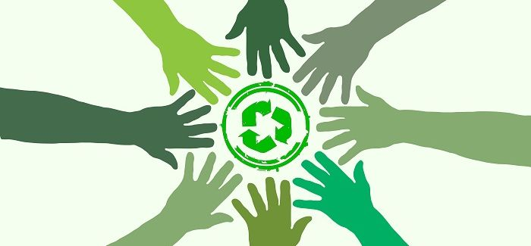**ORGANIZATION PROFILE**

**AN ISO 9001:2015 Certified Organization**

**#-A-302, Definer Serene Drive, Pethanhalli Road, Hosakote, Bangalore-562114**



[**service@ecosaverfoundation.com**](mailto:service@ecosaverfoundation.com)

[**www.ecosaverfoundation.com**](http://www.ecosaverfoundation.com)

**+91-8618897644/9945328062**

Registration No. HSKD654 (23-08-18) / NGO Unique ID- KA/2020/0255637



**Ecosaver Foundation** is a Non-Governmental Organization (NGO) registered under Indian Trust Act 1882. Inspired by its mission & vision, Ecosaver Foundation is working towards creating a brighter & sustainable future. **Ecosaver Foundation** is established and managed by a diverse group of highly experienced professionals. This Foundation is an amalgamation of very young, experienced & dynamic team of experts; our core team comprises environment & resource conservation including water & waste water experts, occupational health & Safety experts, legal compliance management experts, social development, manpower/personals management & Industrial relations experts, financial and institutional experts.

**Ecosaver** **Foundation** has a proud association with different individual experts, agencies and organizations within our country and in overseas as well. Our organization has association with several leading and well recognized laboratory, engineering & consulting firms having competency and expertise in other areas. The associations with experts & firms have not only powered our growth but also helped us to address the deliverables in an integrated fashion.

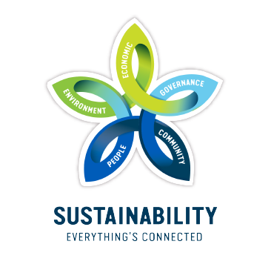

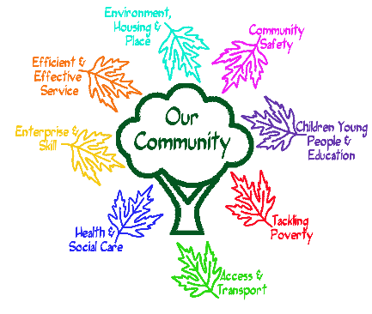

Vision of Ecosaver Foundation is to reach out to general masses with the awareness programs and services to established grassroot level self-sustaining solutions & development frameworks for Society & for overall Environment.



**Our Vision**

**Our mission statements are;**

* To transform & empower the society to build a sustainable future for the community and the planet.
* To assist organization for Sustainable development in its overall Performance to increase profitability and business growth.
* To actively contribute to the social and economic development of the communities in which we operate.
* Continually respond to the changing social realities through the development and application of knowledge, towards development of sustainable society that promote and protects the equality, social justice and Human Rights for all.





**Our Core Values:**

What brings **Ecosaver Foundation,** in providing integrated solutions to diverse areas is its approach of:

* Utilization of local wisdom and resources.
* Encouragement of innovation and creativity.
* Prioritizing Sustainability & quality.
* Enhancing coordination and networking.
* Always ready to accept new challenges
* Integrate quality assurance, transparency, honesty and business ethics into all aspects of our functioning to complete any assignment.

**Our Beliefs are;**

* In the potential power of the poor and Rural people to participate actively in development initiatives within community.
* In equal opportunity for man and women in society irrespective of class, age, ethnic, culture or religion.
* All Human Rights for all.
* In freedom of expression, movement and choice by man and women alike.
* In social harmony free from communal bias.
* Freedom for work, education and sustainable development.

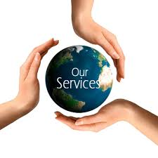

***Ecosaver Foundation*** is working on the global vision of community & sustainable development with utmost local focus. This foundation is working to transform & empower the society to build a sustainable future for the community and our planet

**Various services & Programs that we are offering are;**

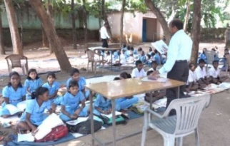

* Social & Environmental awareness and capacity building programs, research and publication based on community requirements.
* Waste Management programs to promote Swacha Bharat Abhiyan.
* Works on Govt. agenda of Climate change & GHGs reduction, Pollution abatements, Water scarcity etc. related projects.
* Forest management/Participatory forest management & afforestation.
* *Works on the capacity Building & Remediation program for Child Labour & Forced Labour issues.*
* *Works on Women empowerment remove gender disparity, human rights, child labor to promote equity and social harmony.*

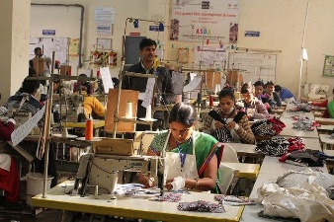

**Capacity Building in Schools & Factories**

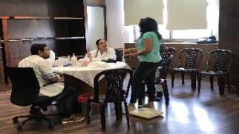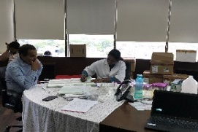

* Propagate eco-technology to enhance efficient resource use.
* Promote community action for socio-economic and eco-development.
* Work on education/upgradation of Health & Hygiene and promotion/development of Health & Hygiene related projects
* Community development programs.
* *Child & adult education to promote Sarva Siksha Abhiyan (SSA).*
* Computer education to promote Information Technology & digital India mission.
* Celebration of events and promotion of days of Social, Scientific & Environmental Importance.
* *Collaborate with institutions having similar work agenda to create excellent work network and developmental frameworks.*

**Health Camps**

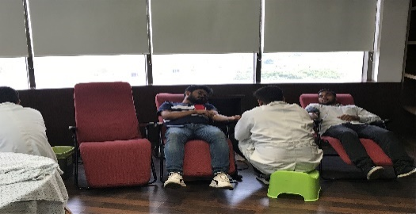

**Blood Donation camps**

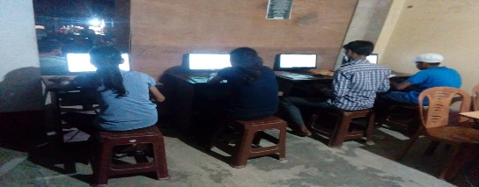

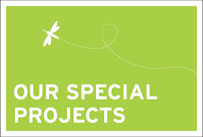

**Computer Education Program**

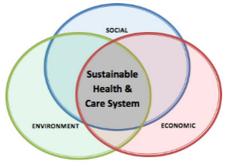

* **Sustainable Health Mission:** This program is exclusively for the school students, local community & factory Workers, through this program our aim is to enhance health & hygiene conditions & capacity buildings.
* **Capacity Building for Modern Slavery:** This program is exclusively designed for the Glass industries in Northern India & Textiles mills & Factories in Southern India. We are in continuous touch with factories & Mills for the Capacity building program & Monitoring of the Child labour & Forced Labour issues to eradicate Modern Slavery.
* **Digital Literacy Mission:** We have started this program to enhance digital literacy among rural India through computer education, Mobile Apps & skill development programs.
* **Greening our Planet:** This program is started to support our Govt.’s Green India Mission, through this we are spreading environmental awareness through seminars, awareness rallies in communities, schools & Factories and Tree plantation in local community.
* **Sustainable Fashion Mission:** Through this project we are are helping customers, brands & factories to move towards sustainable supply chain & circular economy.

**Modern Slavery**



**Digital Literacy Mission**



